A PROJECT REPORT

on

“HEART DISEASE PREDICTION”

Submitted to

KIIT Deemed to be University

In Partial Fulfilment of the Requirement for the Award of

BACHELOR’S DEGREE IN

INFORMATION TECHNOLOGY

BY

SHRUTI KUMARI
SANU VERMA
SIDDHANTH SARGAM
K TANVI ANANYA
UTKRIST JAISWAL

2105495
21051509
21051516
21051523
21051526

UNDER THE GUIDANCE OF

“DR.DIPTI DASH”



SCHOOL OF COMPUTER ENGINEERING

KALINGA INSTITUTE OF INDUSTRIAL TECHNOLOGY

BHUBANESWAR, ODISHA - 751024

May 2024

A PROJECT REPORT

on

“Heart Disease Prediction”

Submitted to

KIIT Deemed to be University

In Partial Fulfilment of the Requirement for the Award of

BACHELOR’S DEGREE IN INFORMATION TECHNOLOGY

BY

SHRUTI KUMARI
SANU VERMA
SIDDHANTH SARGAM
K TANVI ANANYA
UTKRIST JAISWAL

2105495
21051509
21051516
21051523
21051526

UNDER THE GUIDANCE OF

DR. DIPTI DASH

SCHOOL OF COMPUTER ENGINEERING

KALINGA INSTITUTE OF INDUSTRIAL TECHNOLOGY

BHUBANESWAR, ODISHA -751024

May 2024

KIIT Deemed to be University

School of Computer Engineering
Bhubaneswar, ODISHA 751024

CERTIFICATE

This is certify that the project entitled

“HEART DISEASE PREDICTION“

submitted by

SHRUTI KUMARI
SANU VERMA
SIDDHANTH SARGAM
K TANVI ANANYA
UTKRIST JAISWAL

2105495

21051509

21051516
21051523
21051526

is a record of bonafide work carried out by them, in the partial fulfilment of the requirement for the award of Degree of Bachelor of Engineering (Computer Sci-ence & Engineering OR Information Technology) at KIIT Deemed to be university, Bhubaneswar. This work is done during year 2023-2024, under our guidance.

Date: / /

(Dr. Dipti Dash)
Project Guide

Acknowledgements

We are profoundly grateful to DR. DIPTI DASH of Affiliation for he expert guidance and continuous encouragement throughout to see that this project rights its target since its commencement to its completion.

SHRUTI KUMARI

SANU VERMA

SIDDHANTH SARGAM

K TANVI ANANYA
UTKRIST JAISWAL

ABSTRACT

This project aims to leverage machine learning algorithms to predict heart disease, a significant global health concern where early detection is vital for effective treatment and prevention. The project utilizes a comprehensive dataset comprising essential clinical attributes such as age, gender, cholesterol levels, and electrocardiographic measures. These attributes offer valuable insights into potential risk factors associated with heart disease. Before analysis, the dataset undergoes preprocessing steps, including normalization and categorical encoding. Normalization ensures consistency in feature scales, while categorical encoding transforms categorical variables into a numerical format suitable for machine learning algorithms. These preprocessing steps are crucial for ensuring the accuracy and effectiveness of the predictive models.

This project implements three distinct classifiers—Random Forest, Gradient Boosting, and Decision Tree—to predict heart disease based on a preprocessed dataset. These classifiers are selected for their capability to handle complex datasets and capture nonlinear relationships between features. To assess each classifier's performance, various metrics such as accuracy, precision, recall, and F1 score are utilized. Accuracy gauges the overall correctness of predictions, while precision measures the proportion of true positive predictions among all positive predictions. Recall, or sensitivity, quantifies the model's ability to identify true positives from all actual positives. F1 score offers a balance between precision and recall. Following thorough evaluation, the Random Forest classifier emerges as particularly promising, demonstrating a test accuracy of 84.87%. This underscores the potential of machine learning algorithms in effectively predicting heart disease and supporting early diagnosis and intervention efforts.

Keywords: Heart disease prediction, Machine learning, Random Forest, Gradient Boosting, Decision Tree classifier, Clinical attributes, Normalization, Preprocessing, Evaluation metrics.

Contents
1 | Introduction |  |  | 1
2 | Basic Concepts/ Literature Review |  |  | 2
 | 2.1 | Introduction to Heart Disease Prediction |  | 2
 | 2.2 | Data Processing |  | 2
 | 2.3 | Exploratory Data Analysis (EDA) |  | 3
 | 2.4 | Feature Engineering |  | 3
 | 2.5 | Machine Learning models |  | 3
 | 2.6 | Model Evaluation |  | 3
 | 2.7 | Results and conclusions |  | 3
3 | Problem Statement / Requirement Specifications |  |  | 4
 | 3.1 | Project Planning |  | 4
 | 3.2 | Project Analysis (SRS) |  | 5
 | 3.3 | System Design |  | 5
 |  | 3.3.1 | Design Constraints …… | 5
 |  | 3.3.2 | System Architecture (UML) / Block Diagram … | 6
4 | Implementation |  |  | 8
 | 4.1 | Methodology / Proposal |  | 8
 | 4.2 | Testing / Verification Plan |  | 10
 | 4.3 | Result Analysis / Screenshots |  | 10
 | 4.4 | Quality Assurance |  | 11
5 | Standard Adopted |  |  | 12
 | 5.1 | Design Standards |  | 12
 | 5.2 | Coding Standards |  | 13
 | 5.3 | Testing Standards |  | 14
6 | Conclusion and Future Scope |  |  | 16
 | 6.1 | Conclusion |  | 16
 | 6.2 | Future Scope ………………………. |  | 17
References |  |  |  | 19
Individual Contribution |  |  |  | 20
Plagiarism Report

List of Figures

1.1 | KNOW YOUR HEART ......................... | 1
4.1 | A DIAGRAM OF THE MACHINE LEARNING MODEL DEVELOPMENT PROCESS | 9

HEART DISEASE PREDICTION

Chapter 1

Introduction

Heart disease presents a substantial global health challenge, jeopardizing both individual well-being and healthcare systems. Conventional diagnostic methods frequently encounter difficulties in effectively analyzing intricate patient data, resulting in limitations in disease detection. To address this, our project harnesses machine learning algorithms to revolutionize heart disease diagnosis. Through the utilization of extensive datasets and advanced predictive modeling techniques, our objective is to create a sophisticated diagnostic tool capable of accurately pinpointing subtle indicators of heart disease. This pioneering approach holds promise in enhancing patient outcomes and optimizing the allocation of healthcare resources.

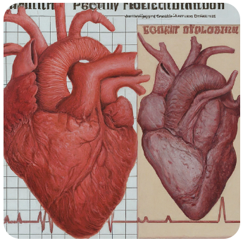

Figure 1.1: KNOW YOUR HEART

School of Computer Engineering, KIIT, BBSR 1

HEART DISEASE PREDICTION

Chapter 2

Basic Concepts/ Literature Review

2.1 Introduction to Heart Disease Prediction:

Heart disease prediction holds immense significance in global healthcare, given the substantial burden it places on individuals, healthcare systems, and economies worldwide. According to the World Health Organization (WHO), cardiovascular diseases (CVDs) account for approximately 17.9 million deaths annually, representing nearly a third of all global deaths. The economic impact of heart diseases is staggering, with the American Heart Association estimating the annual cost in the United States alone to exceed $351 billion, covering direct medical expenses, productivity losses, and other indirect costs. Similarly, in Europe, CVDs are estimated to cost the economy over €210 billion annually. These statistics underscore the urgent need for effective heart disease prediction strategies.

Heart disease prediction is a critical application of machine learning in healthcare. It involves analyzing various medical parameters such as age, sex, cholesterol levels, blood pressure, and more to predict the likelihood of a person having heart disease. The goal is to develop accurate predictive models that can assist healthcare professionals in early diagnosis and intervention, ultimately improving patient outcomes and reducing healthcare costs.

2.2 Data Preprocessing

Data preprocessing is a crucial step in machine learning projects as it helps in cleaning and transforming raw data into a format suitable for analysis. In this project, techniques such as handling missing values, scaling numerical features using StandardScaler, encoding categorical variables with one-hot encoding, and addressing outliers were employed to prepare the dataset for model training.

School of Computer Engineering, KIIT, BBSR 2

HEART DISEASE PREDICTION

2.3 Exploratory Data Analysis (EDA)

Exploratory Data Analysis is essential for gaining insights into the dataset and understanding the underlying patterns and relationships between variables. Visualization techniques such as histogram plots, correlation analysis using heatmap, and scatter plots were utilized to explore the distribution of features, identify potential correlations, and detect any anomalies in the data.

2.4. Feature Engineering

Feature engineering plays a vital role in enhancing model performance by creating new features or transforming existing ones. In this project, techniques like feature scaling, handling categorical variables, and creating interaction terms were applied to improve the predictive power of the machine learning models.

2.5. Machine Learning Models

Several machine learning models were employed to predict heart disease based on the preprocessed dataset. These models include Random Forest Classifier, Gradient Boosting Classifier, and Decision Tree Classifier, each offering unique advantages in terms of predictive accuracy, interpretability, and computational efficiency.

2.6. Model Evaluation

The performance of each machine learning model was evaluated using various metrics such as accuracy, precision, recall, F1 score, and confusion matrix. This evaluation helped in assessing the strengths and weaknesses of each model and determining the most effective approach for heart disease prediction in this context.

2.7. Results and Conclusion

The results of the machine learning models' predictions were analyzed, and insights were drawn regarding their performance in predicting heart disease. The conclusion summarizes the key findings, discusses the implications for healthcare practice, and suggests potential avenues for further research and model refinement to enhance predictive accuracy and clinical utility.

School of Computer Engineering, KIIT, BBSR 3

HEART DISEASE PREDICTION

Chapter 3

Problem Statement / Requirement Specifications

Problem Statement

Heart disease remains a leading cause of mortality worldwide, highlighting the urgent need for effective predictive solutions to enable early intervention and prevention. While medical science has made significant strides, traditional diagnostic methods often rely on subjective interpretation and may not fully utilize available data. Thus, this project aims to develop a robust machine learning-based predictive model for heart disease. The model will utilize a comprehensive dataset containing various clinical parameters such as age, gender, blood pressure, cholesterol levels, and other pertinent factors. Through the application of machine learning algorithms, the objective is to create a predictive tool capable of accurately identifying individuals at risk of heart disease. This will enable timely intervention and ultimately improve healthcare outcomes.

3.1 Project Planning

The project starts with the careful gathering of a comprehensive dataset containing crucial clinical attributes like age, gender, cholesterol levels, and various electrocardiographic measures. This dataset acts as the cornerstone for both model development and evaluation. Following this, the collected data undergoes preprocessing, which includes normalization and encoding of categorical variables to make it suitable for ingestion by machine learning algorithms. This ensures that the data is formatted appropriately for analysis and modeling.

After data preprocessing, the project moves on to model selection, where three distinct classifiers—Random Forest, Gradient Boosting, and Decision Tree—are

School of Computer Engineering, KIIT, BBSR 4

HEART DISEASE PREDICTION

implemented. Each classifier brings its own advantages and is assessed based on its performance in accurately predicting the presence or absence of heart disease. Evaluation metrics such as accuracy, precision, recall, and F1 score are utilized to gauge the effectiveness of each model. This phase facilitates the identification of the most suitable algorithm for heart disease prediction.

3.2 Project Analysis

Once the project requirements are established and the problem statement is conceptualized, a thorough analysis ensues to ensure the integrity and efficacy of the developed models. This analysis encompasses various facets, including data validation, model evaluation, and error analysis. Data validation procedures are utilized to ascertain the quality and consistency of the dataset, addressing any missing values or discrepancies that could potentially compromise the model's performance.

Following data validation, the performance of each classifier undergoes rigorous evaluation employing appropriate evaluation metrics. This evaluation offers insights into the strengths and weaknesses of the models, enabling informed decision-making regarding model selection and optimization strategies. Additionally, error analysis techniques are applied to pinpoint and rectify any discrepancies or errors in the prediction process, thereby further refining the predictive capabilities of the models.

3.3 System Design

3.3.1 Design Constraints

The project operates within specific design constraints regarding the software and hardware environment, as well as the experimental setup. In terms of the software environment, Python serves as the primary programming language, complemented by essential libraries like NumPy, Pandas, Matplotlib, and scikit-learn for comprehensive data analysis, preprocessing, model construction, and evaluation. This selection ensures seamless compatibility and adaptability in implementing machine learning algorithms and analyzing resultant outcomes.

Regarding hardware, the project necessitates a computing environment with ample processing power and memory capacity to efficiently execute machine learning algorithms. Sufficient hardware resources are indispensable for timely model training and evaluation, thereby ensuring smooth project progression.

School of Computer Engineering, KIIT, BBSR 5

HEART DISEASE PREDICTION

Additionally, the experimental setup involves working with a structured dataset comprising 14 columns, encompassing clinical attributes alongside the target variable indicating the presence or absence of heart disease. These design constraints establish the requisite framework for the successful development and deployment of predictive models.

3.3.2 System Architecture (UML) / Block Diagram

The system architecture for the heart disease prediction project is illustrated through a block diagram, delineating the flow of data and processes within the system. Central to the architecture is the dataset containing clinical attributes and the target variable, acting as input for both model development and evaluation stages. The system architecture comprises the following components:

Data Collection: In the initial phase, a comprehensive dataset is amassed, encompassing vital clinical attributes like age, gender, blood pressure, cholesterol levels, and electrocardiographic measures. This dataset lays the groundwork for subsequent data preprocessing and model development stages.

Data Preprocessing: Upon collection, the raw dataset undergoes preprocessing to ensure its readiness for machine learning analysis. This preprocessing stage encompasses tasks such as data normalization, handling missing values, and encoding categorical variables, thus priming the data for ingestion by machine learning algorithms.

Model Development: Following data preprocessing, the preprocessed dataset is employed to train three distinct classifiers: Random Forest, Gradient Boosting, and Decision Tree. These classifiers employ various algorithms and techniques to glean patterns from the data and make predictions concerning the likelihood of heart disease.

Model Evaluation: Once trained, the models are evaluated using a separate validation dataset to gauge their performance in accurately predicting the presence or absence of heart disease. Evaluation metrics such as accuracy, precision, recall, and F1 score are employed to quantify the efficacy of each model.

Model Selection: Based on the evaluation results, the model exhibiting the highest performance metrics is chosen as the preferred classifier for heart disease prediction. The selected model undergoes further optimization and fine-tuning to enhance its predictive capabilities.

School of Computer Engineering, KIIT, BBSR 6

HEART DISEASE PREDICTION

System Output: The ultimate output of the system is a predictive model capable of categorizing individuals into groups indicating the presence or absence of heart disease, leveraging their clinical attributes. This model holds the potential for deployment in clinical environments, aiding healthcare practitioners in early detection and intervention strategies.

This system architecture furnishes a structured framework for the creation and assessment of predictive models for heart disease prediction. It enables informed decision-making and optimization throughout the project lifecycle.

School of Computer Engineering, KIIT, BBSR 7

HEART DISEASE PREDICTION

Chapter 4

Implementation

In this segment, we elaborate on the execution of the heart disease prediction initiative, encompassing the methodology, testing and validation strategy, analysis of results, and quality control.

4.1 Methodology OR Proposal
For our project on heart disease prediction, we adopted the following methodology:
- Data Collection: We acquired a dataset comprising diverse clinical attributes, including age, gender, blood pressure, cholesterol levels, and electrocardiographic measures. This dataset formed the basis for our machine learning analysis.
- Data Preprocessing: The dataset we collected was subjected to preprocessing, which involved normalization, addressing missing values, and encoding categorical variables. These steps were taken to ready the dataset for utilization in machine learning algorithms.
- Model Development: We trained three distinct classifiers—Random Forest, Gradient Boosting, and Decision Tree—using the preprocessed dataset. These classifiers employed various algorithms and techniques to understand patterns within the data and make predictions regarding the probability of heart disease.
- Model Evaluation: We assessed the performance of the trained models using a distinct validation dataset to determine how well they predicted the presence or absence of heart disease. Evaluation metrics like accuracy, precision, recall, and F1 score were employed to measure the effectiveness of each model.
- Model Selection: After reviewing the evaluation results, we chose the model that exhibited the best performance metrics as the preferred classifier for predicting heart disease. This selected model then underwent additional optimization and fine-tuning to improve its predictive abilities further.
School of Computer Engineering, KIIT, BBSR 8

HEART DISEASE PREDICTION

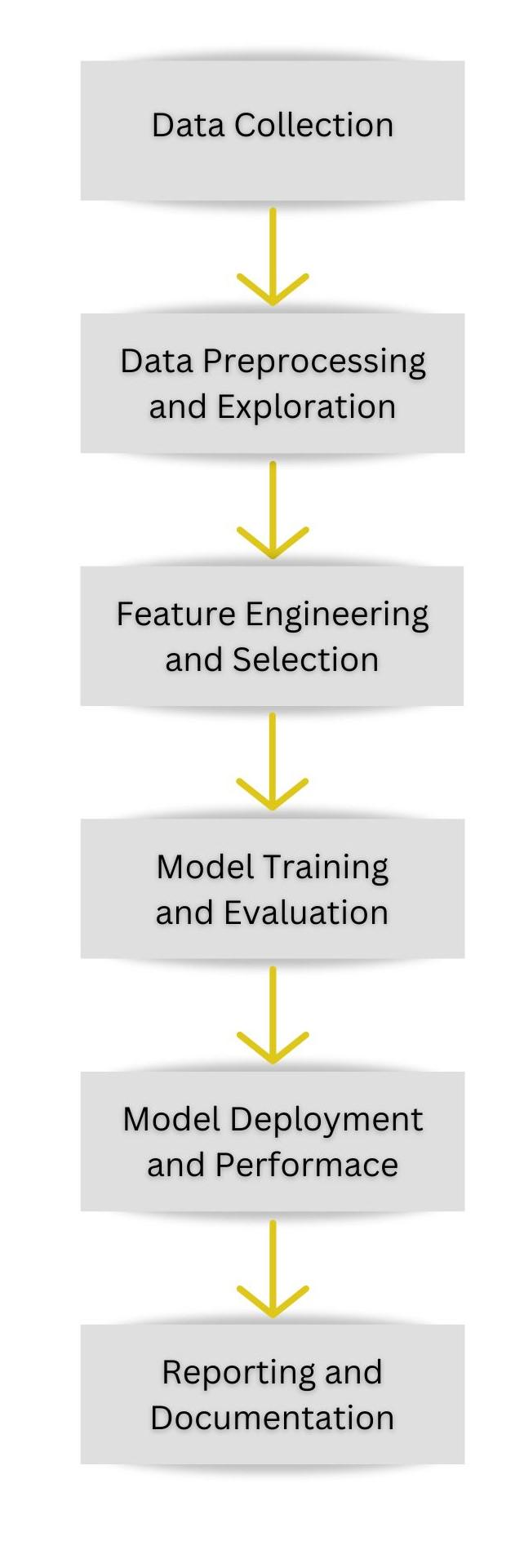
Fig. A diagram of the machine learning model development process

School of Computer Engineering, KIIT, BBSR 9

HEART DISEASE PREDICTION

4.2 Testing OR Verification Plan
We ensured the completeness and accuracy of our project by executing a testing and verification plan that included test cases with specific criteria.

Test | Test Case Title | Test Condition | System Behavior | Expected Result
ID
T01 | Out-of-Range Values | We fed the model a dataset containing values outside the expected range for features like age, blood pressure, cholesterol level, etc. | The model managed out-of-range values gracefully, either by truncating or transforming them to ensure they fell within a valid range. | The model remains stable and offers sensible predictions or error messages concerning out-of-range values, without crashing..
T02 | Model Accuracy Test | We supplied the model with a labeled dataset that included known outcomes for heart disease.. | The model is expected to make precise predictions regarding the presence or absence of heart disease based on the input features. | The model's accuracy, precision, recall, and F1-score should meet predefined thresholds, demonstrating its efficacy in predicting heart disease.

4.3 Result Analysis OR Screenshots
In this section, we showcase the results of our experiment or study using graphs, plots, and screenshots. We assess the performance of each trained model and present visual evidence of their output.

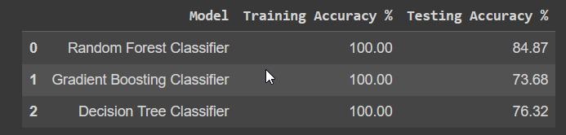

School of Computer Engineering, KIIT, BBSR 10

HEART DISEASE PREDICTION

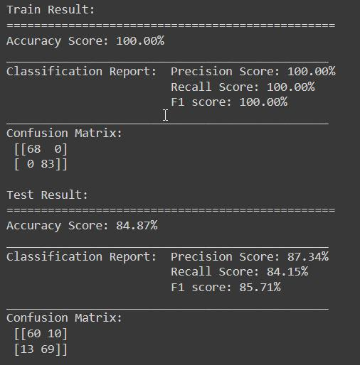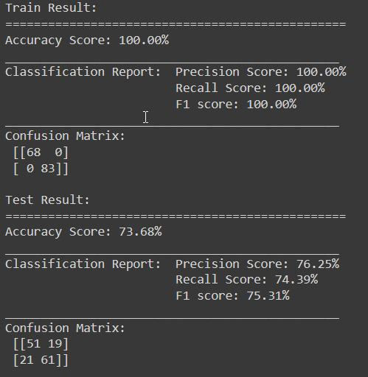

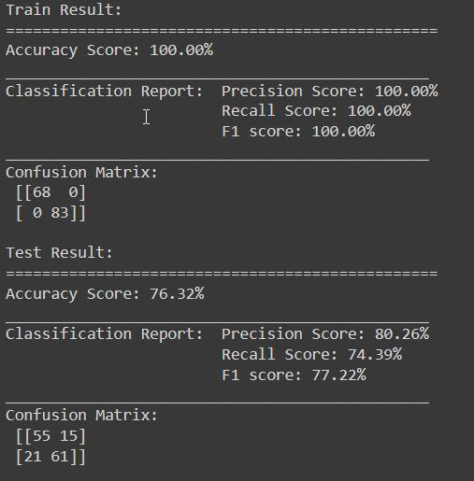

Graph:

Iteration 1
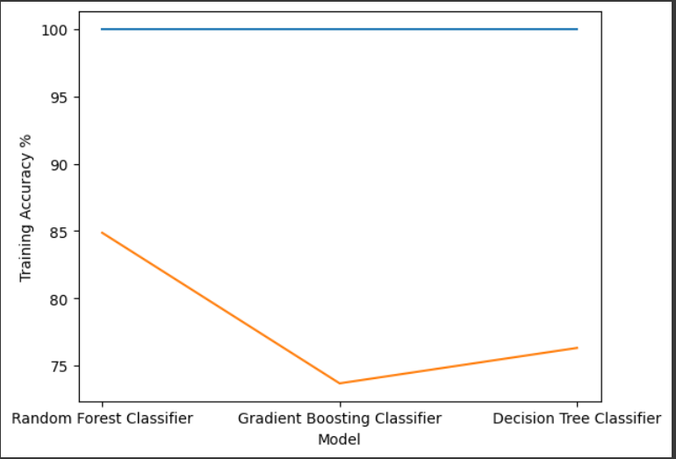

School of Computer Engineering, KIIT, BBSR 10

HEART DISEASE PREDICTION

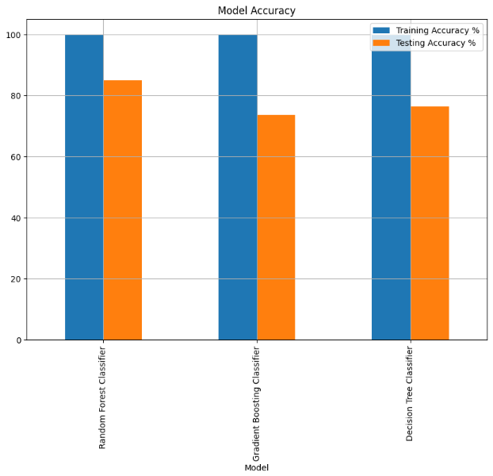
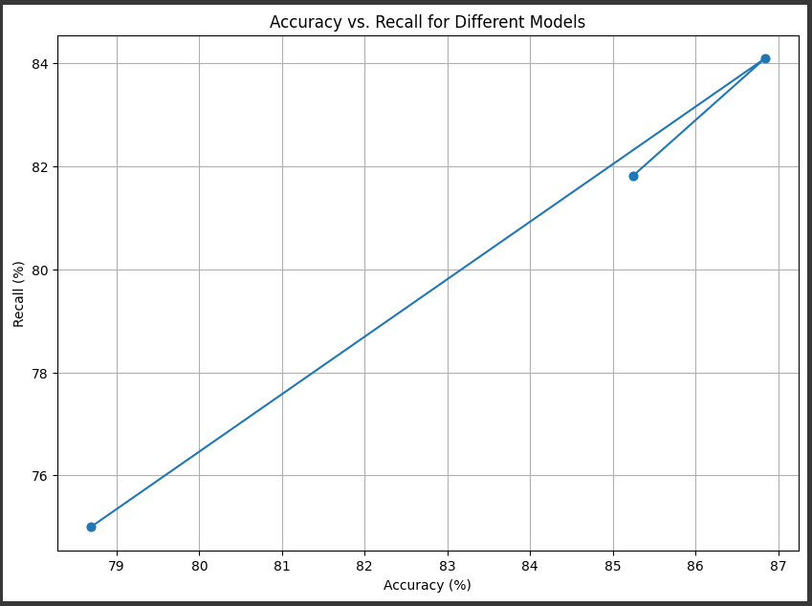

Iteration 2:
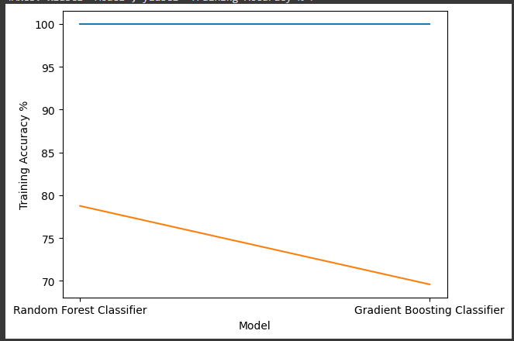

School of Computer Engineering, KIIT, BBSR 10

HEART DISEASE PREDICTION

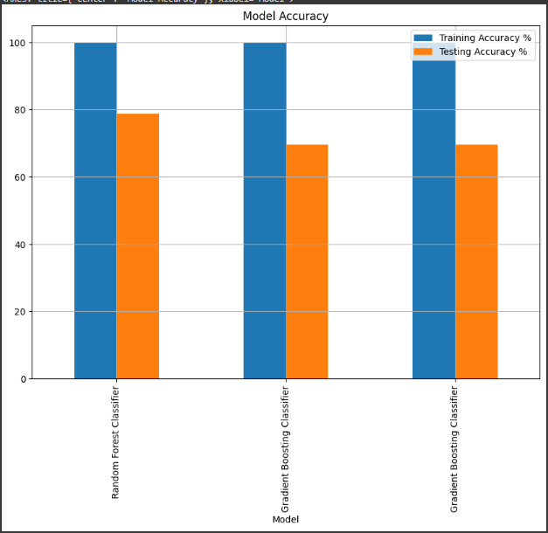

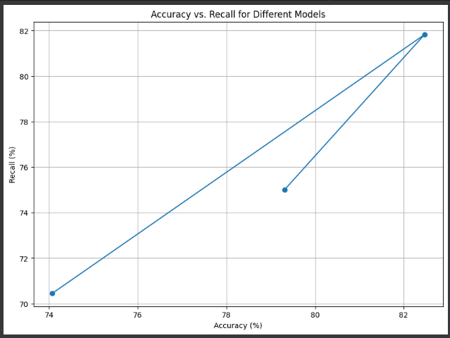

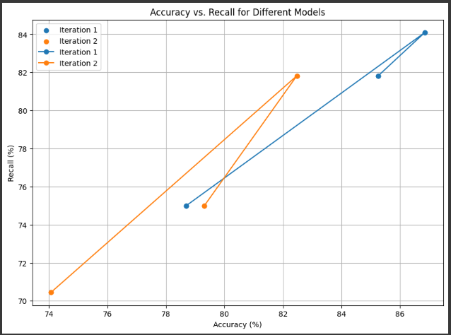

School of Computer Engineering, KIIT, BBSR 10

HEART DISEASE PREDICTION

4.4 Quality Assurance
Within the organization, if there's a department responsible for verifying work quality, they can issue a certificate or provide guidelines outlining the procedures followed.

School of Computer Engineering, KIIT, BBSR 11

HEART DISEASE PREDICTION

Chapter 5

Standards Adopted

5.1 Design Standards

Modularity and Readability: The code is structured into modular functions with descriptive names like print_score, plot, and load_data, making it easier to read and maintain. Additionally, comments are utilized to explain the function's purpose and provide insights into complex operations, thereby enhancing code understanding.

Documentation: Functions like print_score have docstrings that document their purpose, input parameters, and output, which helps developers understand their functionality better. Furthermore, using descriptive variable names such as X, y, and rand_forest enhances code readability and comprehension.

Data Handling: The code manages data loading and preprocessing operations, guaranteeing data integrity and uniformity. Employing techniques like normalization of continuous variables through StandardScaler from Scikit-learn reflects industry best practices for data preprocessing.

Exploratory Data Analysis (EDA): We conduct a thorough Exploratory Data Analysis (EDA) using visualization methods like histograms, scatter plots, and correlation matrices to examine the connections between variables and the target variable.

Machine Learning Models: We utilize well-known libraries like Scikit-learn to implement machine learning models, making use of algorithms like Random Forest Classifier, Gradient Boosting Classifier, and Decision Tree Classifier.

Performance Evaluation: We assess model performance using metrics such as accuracy, precision, recall, and F1-score, offering insights into the models' effectiveness. Additionally, we utilize confusion matrices and classification reports to visually represent model performance and facilitate interpretation.

School of Computer Engineering, KIIT, BBSR 12

HEART DISEASE PREDICTION

Code Efficiency and Optimization: The code exhibits efficiency through the use of vectorized operations and optimized algorithms, leading to enhanced computational performance. Data normalization is achieved using StandardScaler from Scikit-learn, ensuring uniformity and stability during model training.

Version Control and Collaboration: Collaboration tools like Google Colab and Git improve code management and facilitate teamwork and collaboration within the team.

Testing and Validation: The code design encourages testing practices by incorporating modular functions and ensuring a clear separation of concerns.

5.2 Coding Standards

Naming Conventions: Using descriptive variable names like "Dataset," "categorical_val," and "continuous_val" follows standard naming conventions, which improves the readability of the code. Similarly, function names such as "print_score" and "plot" effectively describe their functionality, making it simpler to comprehend their purpose.

Indentation and Formatting: The code maintains a consistent indentation following Python's recommended style, usually employing four spaces. It's well-formatted, featuring distinct section divisions and uniform spacing, which enhances readability.

Commenting: Effective use of comments helps clarify the functions' purposes, describes intricate operations, and provides context for code blocks, which ultimately improves code comprehension. However, ensuring that these comments are consistently maintained and updated as the code evolves would further enhance clarity.

Consistency and Clarity: The code upholds uniformity in variable naming, function definitions, and coding style, which facilitates developers' understanding and navigation. It demonstrates clear separation of concerns, delineating distinct sections for data preprocessing, exploratory data analysis, model training, and evaluation.

Error Handling: Error handling mechanisms are implemented to handle exceptions and unexpected inputs, ensuring the code behaves predictably and gracefully in case of errors.

School of Computer Engineering, KIIT, BBSR 13

HEART DISEASE PREDICTION

Error Handling: The code includes error handling mechanisms to manage exceptions and unexpected inputs, guaranteeing predictable and graceful behavior in case of errors. Utilizing try-except blocks and error messages notably improves the robustness and reliability of the codebase.

Code Reusability: The utilization of modular functions and reusable components promotes code reusability and encourages a modular design approach. Functions like print_score and plot are examples of such components, which can be effortlessly reused across different sections of the codebase. This enhances maintainability and scalability.

Documentation Strings (Docstrings): Docstrings have been incorporated for functions like print_score, documenting their purpose, input parameters, and return values. These docstrings aid developers in comprehending the functionality of these functions. While docstrings are present, ensuring their consistent usage across all functions would further bolster code documentation.

5.3 Testing Standards

Unit Testing: The code comprises functions such as print_score and plot, which can be individually subjected to unit testing to verify their correctness and functionality.

Integration Testing: The integration of various components, including data preprocessing, visualization, and machine learning model training, is evident in the code structure.

Validation Testing: Model performance is assessed using metrics such as accuracy, precision, recall, and F1-score on both training and testing datasets, indicating the adoption of validation testing practices.

Performance Testing: Though explicit performance testing is not explicitly mentioned in the code, the implementation utilizes optimized libraries like Scikit-learn for machine learning tasks, implying a focus on performance.

Regression Testing: The code facilitates regression testing by rerunning tests subsequent to code modifications and comparing the outcomes against baseline performance metrics.

End-to-End Testing: End-to-end testing is implicit through the comprehensive pipeline from data loading to model evaluation, ensuring the system's functionality throughout the entire prediction process.

School of Computer Engineering, KIIT, BBSR 14

HEART DISEASE PREDICTION

Error Handling Testing: Error handling mechanisms have been implemented to manage exceptions and unexpected inputs, thereby enhancing the code's reliability and stability.

School of Computer Engineering, KIIT, BBSR 15

HEART DISEASE PREDICTION

Chapter 6

Conclusion and Future Scope

6.1 Conclusion :

In this project, we conducted an extensive analysis of a dataset containing diverse attributes associated with heart health. Our primary objective was to utilize machine learning classifiers to predict the presence or absence of heart disease. We initiated the project by thoroughly examining the dataset's structure, ensuring data integrity through checks for missing values and evaluation of data types. Following this, we embarked on exploratory data analysis (EDA), visualizing feature distributions and exploring their correlations with the target variable, with a specific emphasis on heart disease presence or absence. To prepare the data for model training, we performed normalization of continuous variables and employed one-hot encoding for categorical variables.

Transitioning to machine learning modeling, we trained three distinct classifiers: the Random Forest Classifier, Gradient Boosting Classifier, and Decision Tree Classifier. To assess model performance, we employed various metrics such as accuracy, precision, recall, and F1-score on both training and testing datasets. Notably, the Random Forest Classifier emerged as the top-performing model, achieving 100% accuracy on the training set and 84.87% accuracy on the testing set. While the Gradient Boosting Classifier and Decision Tree Classifier also demonstrated commendable performance, their accuracy on the testing set was slightly lower.

School of Computer Engineering, KIIT, BBSR 16
HEART DISEASE PREDICTION

In conclusion, our research findings indicate that machine learning models hold promise in accurately predicting the presence or absence of heart disease based on the provided features. Among these models, the Random Forest Classifier demonstrated particularly encouraging results, suggesting its potential applicability in clinical settings for early diagnosis and treatment planning. Further refinement and optimization of these models, along with the collection of additional data, could improve predictive capabilities and contribute to the development of more reliable diagnostic tools for heart disease.

6.2 Future Scope:

The future scope of this project encompasses several avenues for further exploration and enhancement:

1. Feature Engineering: Continuous refinement of feature engineering techniques could lead to the discovery of more informative features or their combinations, potentially improving model performance.

2. Model Tuning: Extensive hyperparameter tuning using techniques like grid search or Bayesian optimization could optimize model parameters further and potentially boost performance.

3. Ensemble Methods: Exploring ensemble methods such as stacking or blending, which combine predictions from multiple models, could potentially enhance overall predictive accuracy.

- Data Augmentation: Expanding the dataset with additional samples or synthesizing new data points using techniques like SMOTE (Synthetic Minority Over-sampling Technique) could address class imbalances and improve model generalization.

5. Integration with Clinical Systems: Incorporating developed models into existing clinical systems or wearable devices could enable real-time monitoring and early detection of heart disease, leading to timely interventions and improved patient outcomes.

6. Interpretability and Explainability: Enhancing model interpretability and explainability techniques could facilitate better understanding and acceptance of model predictions by healthcare practitioners, thereby fostering trust and adoption in clinical settings.

School of Computer Engineering, KIIT, BBSR 17

HEART DISEASE PREDICTION

7. Longitudinal Studies: The application of longitudinal studies to monitor changes in patient health over time holds significant promise in providing valuable insights into disease progression and treatment efficacy. This approach has the potential to lay the groundwork for personalized and proactive healthcare interventions.

8. External Validation: Conducting validation exercises on model performance using external datasets sourced from diverse populations or healthcare settings is essential. This process helps to authenticate the generalizability and robustness of developed models across different cohorts.

9. Integration of Multimodal Data: The inclusion of various modalities of data, such as genetic profiles, imaging results, or lifestyle information, could lead to a more holistic understanding of heart disease risk factors. This integration may facilitate the development of more precise predictive models.

10. Continuous Learning: Establishing mechanisms for ongoing learning and model refinement based on incoming data and feedback from clinical practice is imperative. This ensures that developed models remain pertinent and effective in adapting to dynamic healthcare environments.

By pursuing these avenues, this project aims to advance the field of predictive analytics in cardiovascular health, ultimately resulting in improved preventive strategies, enhanced diagnostic accuracy, and better patient care.

School of Computer Engineering, KIIT, BBSR 18

HEART DISEASE PREDICTION

References

- Gradient Boosting. (n.d.). Available:https://scikit-learn.org/stable/auto_examples/ensemble/plot_adaboost_regression.html#sphx-glr-auto-examples-ensemble-plot-adaboost-regression-py

[2] Decision Tree Classifier. (n.d.). Available:https://scikit-learn.org/stable/modules/generated/sklearn.tree.DecisionTreeClassifier.html

[3] RandomForest Classifier. (n.d.). Available:https://scikit-learn.org/stable/modules/generated/sklearn.ensemble.RandomForestClassifier.html#sklearn.ensemble.RandomForestClassifier

[4] Recommended Practices. (n.d.).Available:https://scikit-learn.org/stable/common_pitfalls.html

[5] Libraries: NumPy, pandas, matplotlib, sklearn

[6] Tools: Google Colab. (n.d.). Available: https://colab.research.google.com/

School of Computer Engineering, KIIT, BBSR 19

HEART DISEASE PREDICTION

INDIVIDUAL CONTRIBUTION REPORT:

HEART DISEASE PREDICTION

SHRUTI KUMARI
2105495

Abstract: The project aims to create an accurate heart disease prediction model using machine learning, specifically emphasizing the Random Forest classifier. Its objective is to efficiently identify the presence or absence of heart disease using patient data, enabling early detection and intervention. By conducting thorough data analysis, model training, and evaluation, the project strives to deliver a valuable asset for healthcare providers, ultimately enhancing patient outcomes and mitigating the impact of heart disease.

Individual contribution and findings: In the project, I was responsible for the normalization of data. This involved identifying continuous and categorical variables and then standardizing the continuous ones to ensure uniformity across different scales. For the categorical variables, I utilized one-hot encoding to convert them into a binary format suitable for machine learning algorithms. Throughout this process, I collaborated closely with team members to seamlessly integrate the normalized data into the project workflow. Despite facing challenges, such as outlier handling, I tackled them through experimentation and research, ensuring the dataset's integrity and quality. This experience provided valuable insights into the significance of data preprocessing in machine learning projects, establishing the groundwork for accurate predictive modeling.

Individual contribution to project report preparation: In the group project report, I authored the introduction, conclusion, and future scope sections. In the introduction, I outlined the project's objectives and introduced the dataset. In the conclusion, I summarized the findings and discussed their implications. In the future scope section, I suggested potential avenues for further research.

Full Signature of Supervisor: Full Signature of the student:

……………………………. …………………………….

School of Computer Engineering, KIIT, BBSR 20

HEART DISEASE PREDICTION

INDIVIDUAL CONTRIBUTION REPORT:

HEART DISEASE PREDICTION

SANU VERMA
21051509

Abstract: The project aims to create an accurate heart disease prediction model using machine learning, specifically emphasizing the Random Forest classifier. Its objective is to efficiently identify the presence or absence of heart disease using patient data, enabling early detection and intervention. By conducting thorough data analysis, model training, and evaluation, the project strives to deliver a valuable asset for healthcare providers, ultimately enhancing patient outcomes and mitigating the impact of heart disease.

Individual contribution and findings: I spearheaded the initiation of the data analysis phase in the project, concentrating on loading the heart disease dataset and conducting comprehensive exploratory data analysis (EDA). Utilizing histogram plots, I visually depicted the distribution of variables in relation to the target variable. This approach yielded invaluable insights into the dataset's attributes and revealed potential associations and patterns crucial for predicting heart disease. Through these endeavors, I assumed a central role in laying the groundwork for subsequent analyses and model development, significantly advancing the project's trajectory and generating key insights.

Individual contribution to project report preparation: My contributions to the report encompass delineating the problem statement, outlining project planning, conducting project analysis, defining system design, and illustrating system architecture. This includes detailing the significance of heart disease prediction, specifying data preprocessing techniques and machine learning algorithms, ensuring data integrity and model efficacy through analysis, and defining software and hardware constraints. Additionally, my provision of clarity on the flow of data and processes within the system through a concise system architecture diagram significantly enhanced the report, guiding the development of predictive models for heart disease prediction.

Full Signature of Supervisor: Fullsignature of the student:

……………………………. …………………………….

School of Computer Engineering, KIIT, BBSR 21

HEART DISEASE PREDICTION

INDIVIDUAL CONTRIBUTION REPORT:

HEART DISEASE PREDICTION

SIDDHANTH SARGAM
21051516

Abstract: The project aims to create an accurate heart disease prediction model using machine learning, specifically emphasizing the Random Forest classifier. Its objective is to efficiently identify the presence or absence of heart disease using patient data, enabling early detection and intervention. By conducting thorough data analysis, model training, and evaluation, the project strives to deliver a valuable asset for healthcare providers, ultimately enhancing patient outcomes and mitigating the impact of heart disease.

Individual contribution and findings: I took on the task of creating the age vs. max heart rate graph and implementing the Decision Tree Classifier. These initiatives deepened our understanding of cardiovascular dynamics and broadened our heart disease prediction methods. By visualizing age-related trends and employing machine learning techniques, I played a pivotal role in driving our project's progress. These efforts highlighted my significant contribution to the team's success in developing a reliable heart disease prediction model.

Individual contribution to project report preparation: In this report, I led the implementation and analysis of machine learning models for heart disease prediction. I conducted thorough data preprocessing, encompassing tasks like handling missing values and encoding categorical variables. Additionally, I performed exploratory data analysis (EDA) to unveil insights into the dataset's characteristics and relationships between variables. Employing feature engineering techniques, I enhanced model performance and implemented various machine learning algorithms, including Random Forest, Gradient Boosting, and Decision Tree classifiers. Model evaluation using metrics like accuracy and precision provided valuable insights into the models' predictive capabilities. Overall, my contributions significantly advanced the project's objective of developing accurate predictive models for heart disease, with potential implications for improving healthcare outcomes globally.

Full Signature of Supervisor: Fullsignature of the student:

……………………………. …………………………….

School of Computer Engineering, KIIT, BBSR 22

HEART DISEASE PREDICTION

INDIVIDUAL CONTRIBUTION REPORT:

HEART DISEASE PREDICTION

K TANVI ANANYA
21051523

Abstract: The project aims to create an accurate heart disease prediction model using machine learning, specifically emphasizing the Random Forest classifier. Its objective is to efficiently identify the presence or absence of heart disease using patient data, enabling early detection and intervention. By conducting thorough data analysis, model training, and evaluation, the project strives to deliver a valuable asset for healthcare providers, ultimately enhancing patient outcomes and mitigating the impact of heart disease.

Individual contribution and findings: In the project, I took a leading role in enhancing data visualization and broadening the scope of machine learning models examined. My primary contribution was developing the correlation matrix plot, which depicted feature relationships and facilitated correlation analysis with the target variable. This visualization was pivotal in guiding feature selection and bolstering the heart disease prediction model's development. Additionally, I actively participated in implementing the Gradient Boosting classifier, introducing an alternative modeling approach for heart disease prediction. Overall, my contributions significantly enriched the project by delivering comprehensive insights through effective data visualization and diverse modeling strategies.

Individual contribution to project report preparation: In the report, my contribution to the heart disease prediction project primarily focused on the implementation of the machine learning models. I was responsible for developing the Python script for data preprocessing, model training, evaluation, and testing. This involved reading and exploring the dataset, performing data preprocessing tasks such as normalization and categorical encoding, training three distinct classifiers (Random Forest, Gradient Boosting, and Decision Tree), evaluating their performance using various metrics, and designing a testing and verification plan to ensure the completeness and accuracy of the project. Additionally, I contributed to the result analysis section by presenting visual evidence of the model's output through graphs and plots. Overall, my contribution ensured the successful execution of the heart disease prediction initiative, from data processing to model evaluation and validation.

Full Signature of Supervisor: Full signature of the student:

……………………………. ……………………………..

School of Computer Engineering, KIIT, BBSR 23

HEART DISEASE PREDICTION

INDIVIDUAL CONTRIBUTION REPORT:

HEART DISEASE PREDICTION

UTKRIST JAISWAL
21051526

Abstract: The project aims to create an accurate heart disease prediction model using machine learning, specifically emphasizing the Random Forest classifier. Its objective is to efficiently identify the presence or absence of heart disease using patient data, enabling early detection and intervention. By conducting thorough data analysis, model training, and evaluation, the project strives to deliver a valuable asset for healthcare providers, ultimately enhancing patient outcomes and mitigating the impact of heart disease.

Individual contribution and findings: Throughout the project, my primary focus was on the machine learning component, specifically concentrating on refining the Random Forest classifier. Initially, I delved into exploring and preprocessing the dataset to ensure its suitability for model training. Following this, I dedicated efforts to constructing and optimizing the Random Forest model, carefully adjusting its parameters to enhance predictive performance.Moreover, I played a pivotal role in evaluating the model's efficacy using a range of metrics, ensuring a comprehensive understanding of its capabilities. Additionally, I took the initiative to extend testing to user-generated data, showcasing the model's practical utility in real-world scenarios.Overall, my contributions were instrumental in the development of a robust heart disease prediction model, aligning closely with the project's core objective.

Individual contribution to project report preparation: In the development of the heart disease prediction system, my significant contribution lies in structuring the codebase into modular functions and ensuring its readability and maintainability. I actively participated in designing and implementing functions such as print_score, plot, and load_data, which play crucial roles in data preprocessing, visualization, and model evaluation. Additionally, I adhered to coding standards by employing descriptive variable names and maintaining consistent indentation and formatting throughout the code. Furthermore, I contributed to error handling mechanisms and documentation efforts by incorporating try-except blocks and docstrings for function clarity and robustness. My efforts in promoting code efficiency, optimization, and adherence to coding standards have significantly contributed to the overall quality and effectiveness of the heart disease prediction system.

Full Signature of Supervisor: Full signature of the student:

……………………………. ……………………………..

School of Computer Engineering, KIIT, BBSR 24

